SQL Technical Annex
All major SQL statements used for setting up and cleaning up the database can be divided into 4 parts:
Part A: SQL statements use for start up the schema.
Part B: SQL statements use for clean up the schema.
Part C: SQL statements use for grant privileges to MySQL users.
Part D: SQL statements use for insert some test data.

Part a Start up the Schema
- Since the Auto Increment will be used for allocating ID automatically in some table. To make sure the Auto Increment works, set the default storage engine to INNODB before running create table statements.

SET default_storage_engine = INNODB;

- Create tables.
  - When Create a new table, use the constraint syntax to constraint foreign key columns with NO ACTION option. Example:

CREATE TABLE IF NOT EXISTS Product (
id INT AUTO_INCREMENT,
….
active BOOLEAN NOT NULL DEFAULT false,
PRIMARY KEY (id),
CONSTRAINT product_flavour_fk
FOREIGN KEY (flavour_id)
REFERENCES Flavour (id)
ON UPDATE NO ACTION ON DELETE NO ACTION,
CONSTRAINT product_type_fk
FOREIGN KEY (storage_type_id)
REFERENCES StorageType (id)
ON UPDATE NO ACTION ON DELETE NO ACTION,
CONSTRAINT product_chk
CHECK (
cost > 0 AND
weight > 0 AND
health_factor >= 0 AND
health_factor <= 1
)
);

  - Because MySQL does not support CONSTRAINT CHECK in any of the storage engines (only support the syntax but the constraint does not work), use a trigger for each table to check in insert value is valid or not. Example:

DELIMITER $$
CREATE TRIGGER product_before_insert BEFORE INSERT ON Product
FOR EACH ROW
BEGIN
IF NEW.cost <= 0 THEN
SIGNAL SQLSTATE '12345'
SET MESSAGE_TEXT = 'cost must be greater than 0.';
END IF;
IF NEW.weight <= 0 THEN
SIGNAL SQLSTATE '12345'
SET MESSAGE_TEXT = 'weight must be greater than 0.';
END IF;
IF NEW.health_factor < 0 || 1 < NEW.health_factor THEN
SIGNAL SQLSTATE '12345'
SET MESSAGE_TEXT = 'health_factor must between 0 and 1.';
END IF;
END$$
DELIMITER ;

- Create views. Use joins projection to create views. Example:

CREATE VIEW ProductDetail AS
SELECT
Product.name AS name,
Flavour.flavour AS flavour,
StorageType.typename AS storage_type,
Product.cost AS cost,
Product.weight AS weight,
Product.instock AS instock,
Product.health_factor AS health_factor,
Product.active AS active,
Product.id AS id,
Flavour.id AS flavour_id,
StorageType.id AS storage_type_id
FROM
Product, Flavour, StorageType
WHERE
Flavour.id = Product.flavour_id AND
StorageType.id = Product.storage_type_id;

Part B Clean Up the Schema
First, drop all views in the negative direction of create views. Example:

DROP VIEW IF EXISTS SalesRecordDetail;
……
DROP VIEW IF EXISTS ProductDetail;

Then drop all tables in the negative direction of create tables (if use same direction of creation, foreign key will restrict the dropping). For each table, drop the insert triggers before dropping the table. Example:

DROP TRIGGER IF EXISTS salesrecord_before_insert;
DROP TABLE IF EXISTS SalesRecord;
……
DROP TRIGGER IF EXISTS flavour_before_insert;
DROP TABLE IF EXISTS Flavour;

Part C Grants
Use 14ac3u07 as the database admin user and other 3 users as the PHP connecting users. Since there are only 3 non-admin users to use, but 5 different roles on system, we have to let some roles share the same MySQL user.

For the administrator role in the system, use 14ac3user07 as their MySQL user. They can edit data, but they are not allowed to change the schema or do granting.

GRANT SELECT, INSERT, UPDATE, DELETE ON 14ac3d07.* TO '14ac3user07'@'%';

For the CEO, manager, accountant roles & PHP login connection, use 14ac3extra07 as their MySQL user. They can only use select in the schema.

GRANT SELECT ON 14ac3d07.* TO '14ac3extra07'@'%';

Use 14ac3other07 for buyer role, they can only have accessibility to those data which is related to 'what goods are you shipping to our country' topic.

GRANT SELECT ON 14ac3d07.MarketDetail TO '14ac3other07'@'%';
GRANT SELECT ON 14ac3d07.ProductDetail TO '14ac3other07'@'%';
GRANT SELECT ON 14ac3d07.Market TO '14ac3other07'@'%';
GRANT SELECT ON 14ac3d07.Country TO '14ac3other07'@'%';
GRANT SELECT ON 14ac3d07.Product TO '14ac3other07'@'%';

Part D Insert Test Data
When insert test data, use functions to get some random values. Example:

delimiter $$
CREATE FUNCTION getRandBoolean (p DOUBLE) RETURNS BOOLEAN
BEGIN
IF rand() <= p THEN
RETURN(true);
ELSE
RETURN(false);
END IF;
END$$
delimiter ;

For some tables (most of the entity’s table), write the insert statements manually to insert data.

INSERT INTO User (id, name, password, permission_type, active) VALUES (1, 'admin A', sha1('123456'), 'admin', true);
……
INSERT INTO User (id, name, password, permission_type, active) VALUES (12, 'accountant C', sha1('123456'), 'accountant', false);

For other tables, use the “insert into … select …” syntax. Example:

INSERT INTO TransportOffer
(storage_type_id, country_name, transport_company_name, price_per_kg)
SELECT
StorageType.id AS storage_type_id,
Country.name AS country_name,
TransportCompany.name AS transport_company_name,
getRandDouble(0.5, 0.75, 2) AS price_per_kg
FROM
StorageType, Country, TransportCompany;

USER GUIDE
1. Getting started:

1.1 Login

To log in the system the user simply needs to provide his username and password and press the “OK” button. The user is then automatically redirected to his homepage based on his user type.
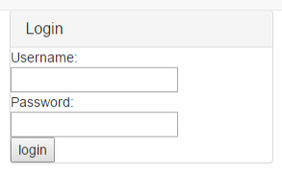

1.2 Log out

To log out the system the user needs to press the Log out button. This button can be found at the right left corner of the menu bar. By pressing this button the user is redirected to the login page.
Note: This button is only available after a successful login attempt.

2. Types of users:

2.1 Visitor/Buyer:

The system has a Visitor type user who acts as an 'anonymous' therefore no authentication is required. By choosing the 'Request an Offer' at the login page the visitor is automatically redirected to a page.

  - Manager/Accountant:

After a successful login attempt a Manager can do numerous combination of queries using the interface provided.

2.2.1 Specifying a query

Step 1 (Selecting the known values)

The first column of checkbox in each section represents a “known” relation. By checking this checkbox the manager can tell the system that the query should run based on that restriction. The user can then select or write the known value the input field next to the checkbox.

Example: Selecting a country restriction where Country equals United Kingdom:
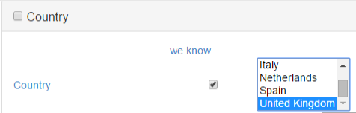

Step 2 (Selecting the attributes we want to know)

Next to the attribute at the last column of each section the checkbox represents the value that the manager wants to include as a fiend in the query. By selecting a value in a table it will automatically result to include the table and that attribute to the query.

Example (Selecting Country as the wanted value)
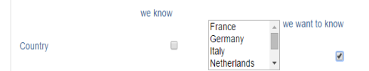

Note: It is possible to select an attribute both known and wanted if we want to see the known attribute as a column in the answer.

Step 3: (Selecting Routers)

Usually the query can be unambiguous for the system and the manager needs to specify a root. This necessary when two selected attribute in two different table can be connected together using more than one possible Unit.

Example: (Selecting a product in a Specific Country)

1.

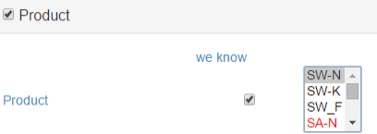
2.
3.
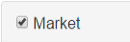

Since product can have Contract, Transportoffer and Market in a country we need to specify the Market as a 'Router' by checking the checkbox at the headline of the section

2.2.2 Error Handling:

When a query is unambiguous an error message appears at the top of the page. (User needs to scroll up to see the message). This error message contains meaningful information on what is unclear about the query and what should be done to make it clear.

2.2.3 Reading the result:

The result appears in the button of the page in table format. (Usually the user needs to scroll down to see the message.)

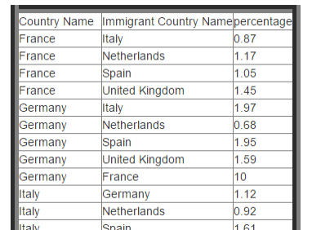

2.3 Admin

2.3.1 Create:

An administrator can create new entities to the table. To be able to do so a meaningful interface has been provided. To create a new entity scroll down until the required entity and fill the required fields.

Note: It is necessary to fill all fiends in a section in order to create an entity.

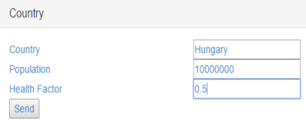
Example: Creation of a new country:
2.3.1.1 For the admin to insert a new Country he must choose a new country name and population number for the new Country and then click Submit. The information will be added to the table with name Country.
2.3.1.2 To insert into Immigrants the admin must choose the country from which the Immigrants are coming from and add them to the Country they are in and what percentage are there in this country and then press Submit. Then the information will be added into Immigrants table and so on.
2.3.1.3 Error Handling:

When not all required fields are filled an error message appears at the top of the page

2.3.1.4 Successful Creation

A Successfully message appears following a successful entity creation.

2.3.2 Delete:

An administrator can delete entities from the Database. A helpful interface was provided to help to perform this type of operation. Sometimes an Entity can be specified multiple other entities and can become hard. The interface only allow to select the right combinations

Example (Deleting a market)
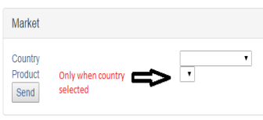
2.3.2.1 For an admin to delete a Country from the database all he needs to do it select that country from the dropdown menu and click delete on that menu box.
2.3.2.2 For an admin to delete Immigrants from the database all he needs to do it select the origin country of the immigrants from the dropdown menu and then select the country that they are located at the moment, and then click delete on that menu box.
2.4 CEO

The CEO view enables the user to see the data in a special way. The Graph represents the average benefit for sold product in time. The vertical axes represents the time and the horizontal represents the average benefit in one particular time.
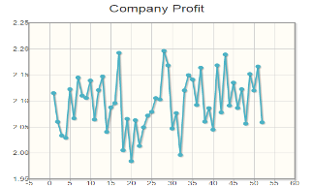

2.4.1 Find the wrong manager.

By specifying a user below the graph a CEO can see the graph based on one individual Managers decision allowing them to identify who is to blame

3. Data Types:

Country name  Transport company name  Date  Food type  Food taste  Immigrants percentage  Market Volume  Market Potencial  Price  Health factor  Weigth | String  String  Date in the format (yyyy-mm-dd)  String  String  Doube 0 < = x < =100  Integer  Double  Double x > 0  Double 0 <= x <=1 | Quantity  Storage type name | Integer  String

